Monitor Docker Container with Grafana & Prometheus


1. Launch ubuntu 20/22 with below ports in AWS
9393,3000,9090
2. Login your machine and install docker
apt-get update
apt-get install docker.io -y
apt-get install docker-compose -y
3. To Monitor docker we need to deploy some container so then create one folder name as mysqldocker and go to that folder and inside that create backup folder to pvc
mkdir mysqldocker
cd mysqldocker
mkdir backup
4. then create a 1 docker-compose.yml file to run one docker container
version: '3.3'
services:
mysql:
image: mysql:8.0.26
restart: always
environment:
MYSQL_ROOT_PASSWORD: root
volumes:
- /home/ubuntu/mysqldocker/backup:/var/lib/mysql
ports:
- "3306:3306"
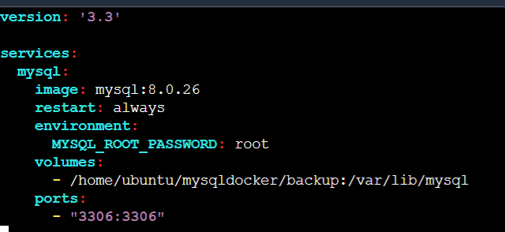
5. and then up that docker-compose file and check your mysql container are running
docker-compose up -d
docker ps
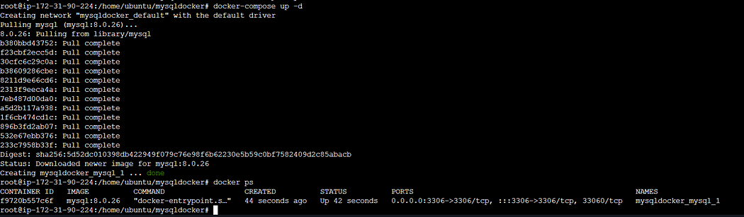
6. again go /home/ubuntu and these time again create tomcat file
version: '3'
services:
tomcat:
image: tomcat:10-jdk17-openjdk-slim
ports:
- "8080:8080"
volumes:
- ./webapps:/usr/local/tomcat/webapps
- ./logs:/usr/local/tomcat/logs
restart: always
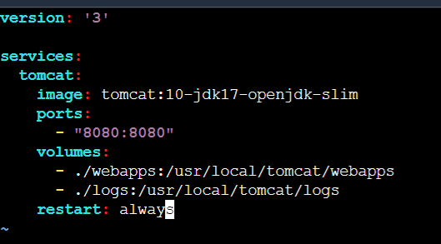
7. and again follow step number 5. and these time you will see 2 container running
8. Now we install Prometheus and grafana first will see installation of Prometheus and then grafana
##################Prometheus############################
#Download the latest version of Prometheus using the following command:
wget https://github.com/prometheus/prometheus/releases/download/v2.30.0/prometheus-2.30.0.linux-amd64.tar.gz
#Extract the downloaded archive:
tar xvfz prometheus-2.30.0.linux-amd64.tar.gz
#Move into the extracted directory:
cd prometheus-2.30.0.linux-amd64
#Start Prometheus as a background service:
./prometheus --config.file=prometheus.yml &
9. After proper installation and run Prometheus you see following output on cli and on browser (public ip:9090)
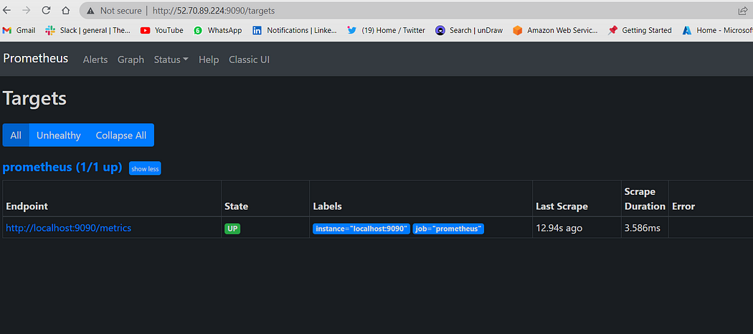
#####################Grafana############################\
#Import the GPG key used by the Grafana package:
wget -q -O - https://packages.grafana.com/gpg.key | sudo apt-key add -
#Add the Grafana repository to the APT sources:
sudo add-apt-repository "deb https://packages.grafana.com/oss/deb stable main"
#Update the package lists:
sudo apt update
#Install Grafana:
sudo apt install grafana
#Start the Grafana service:
sudo systemctl start grafana-server
#Enable the Grafana service to start on system boot:
sudo systemctl enable grafana-server
10. After Proper Installation of Grafana you will see following output on cli and browser (public ip:3000)
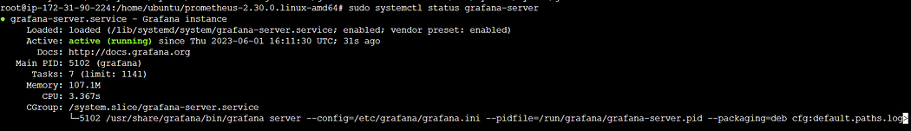
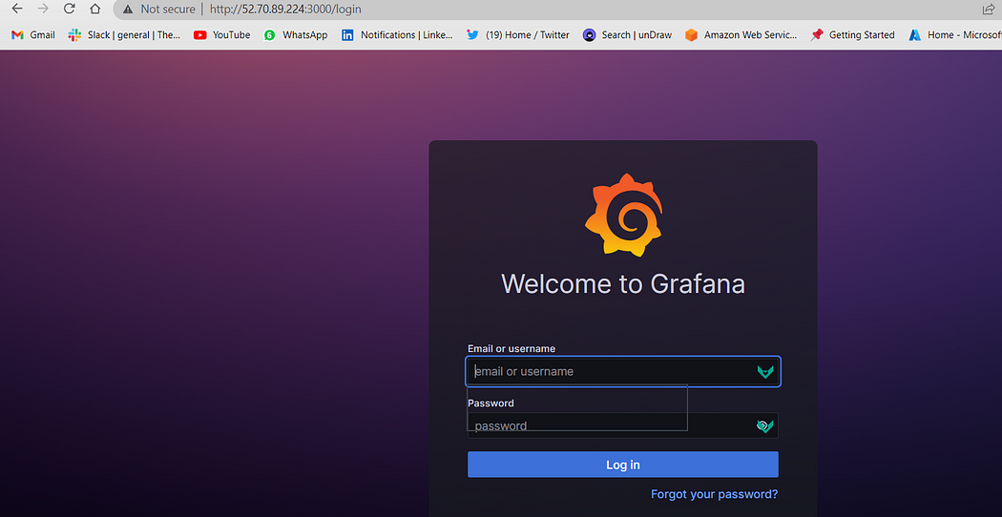
11. You can login grafana with default “User= admin”, “Password=admin”
12. Now modify daemon.json file to gather metrics of docker (there is no by default daemon.json you need to create it)
cd /etc/docker
vi daemon.json
#these is daemon.json file content
{
"metrics-addr" : "0.0.0.0:9393",
"experimental" : true
}
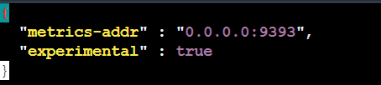
13. Now restart the docker
systemctl restart docker
14. and now hot public ip with port 9393 you will get docker metrics make sure you use following syntax “Public IP:9393/metrics”
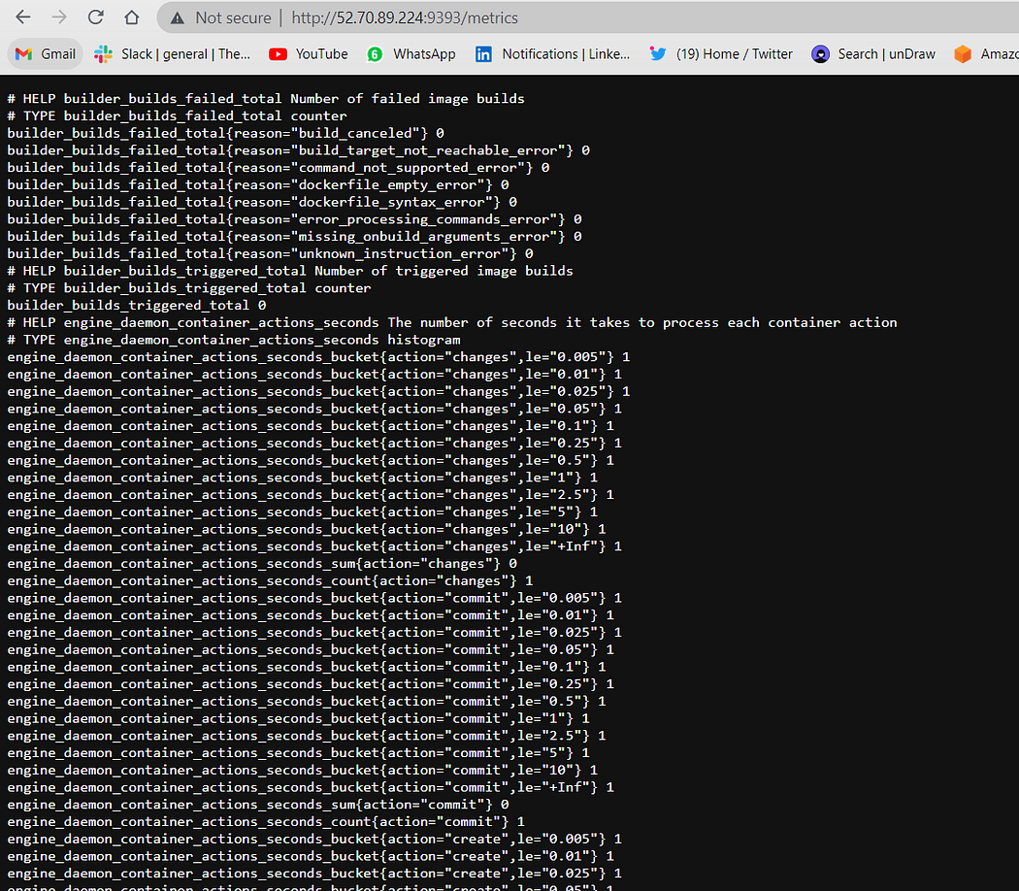
15. If you want stop Prometheus (Not required but additional information)(Optional Step)
ps aux | grep prometheus
kill -SIGTERM <PID>
16. Now modify the configuration in promethus.yml where you install Prometheus
cd /home/ubuntu/prometheus-2.30.0.linux-amd64
vi prometheus.yml
17. Delete default file with “dd” option and paste it following file and save it
# my global config
global:
scrape_interval: 15s
evaluation_interval: 15s
# Alertmanager configuration
alerting:
alertmanagers:
- static_configs:
- targets:
# - alertmanager:9093
# Load rules once and periodically evaluate them according to the global 'evaluation_interval'.
rule_files:
# - "first_rules.yml"
# - "second_rules.yml"
# A scrape configuration containing exactly one endpoint to scrape: Prometheus itself.
scrape_configs:
- job_name: "prometheus"
static_configs:
- targets: ["localhost:9090"]
- job_name: "Docker Job"
static_configs:
- targets: ["Public IP:9393"]
Note: Make sure you replace the public ip
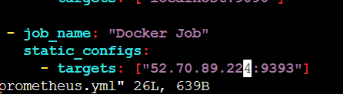
18. now go again in Prometheus and check whether target resource is up or not for that go to “Prometheus > Status > targets”
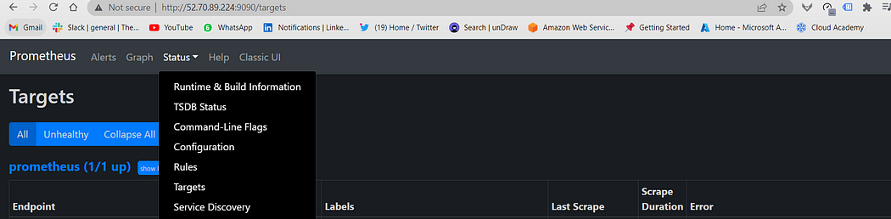
19. If you wont see output then follow step no 15. and again start Prometheus then you will see following output
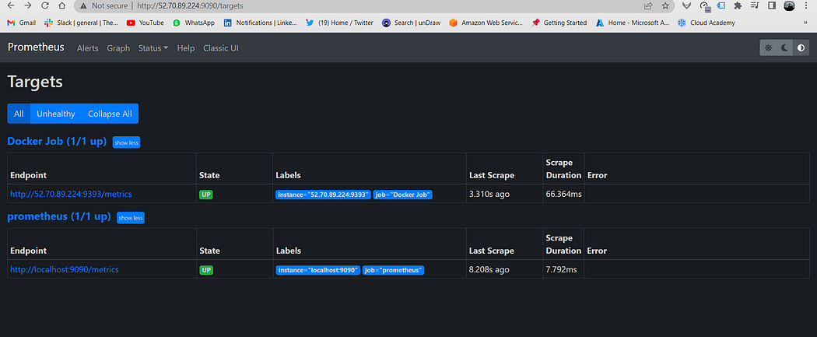
20. then go to grafana login with credentials
21. then click on “Administration => Data Source => Prometheus => and add Prometheus url”
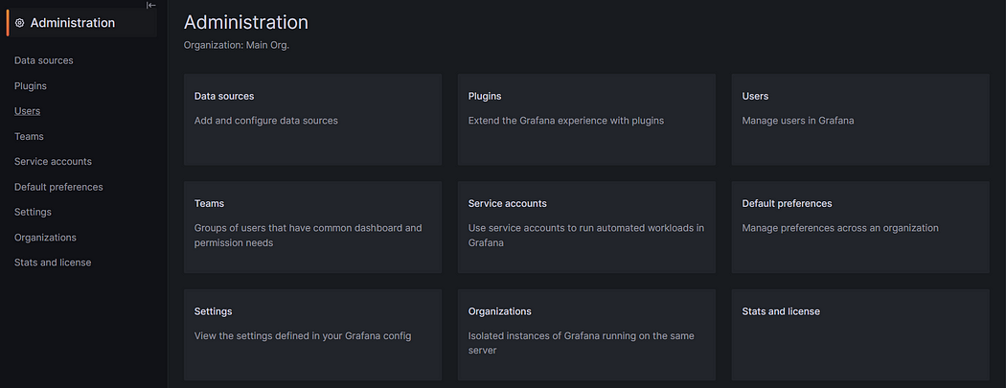
Administration
22. Then click on “Data Source”
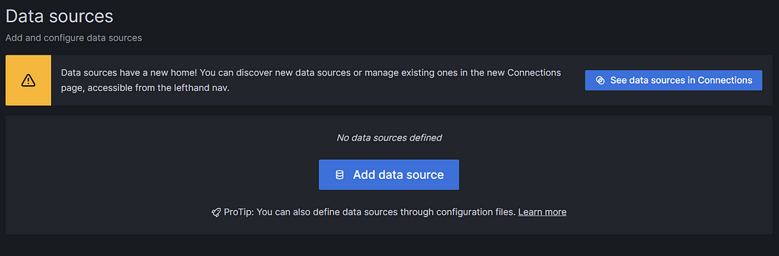
Data Source
23. Click on Add Data Source and select “Prometheus”
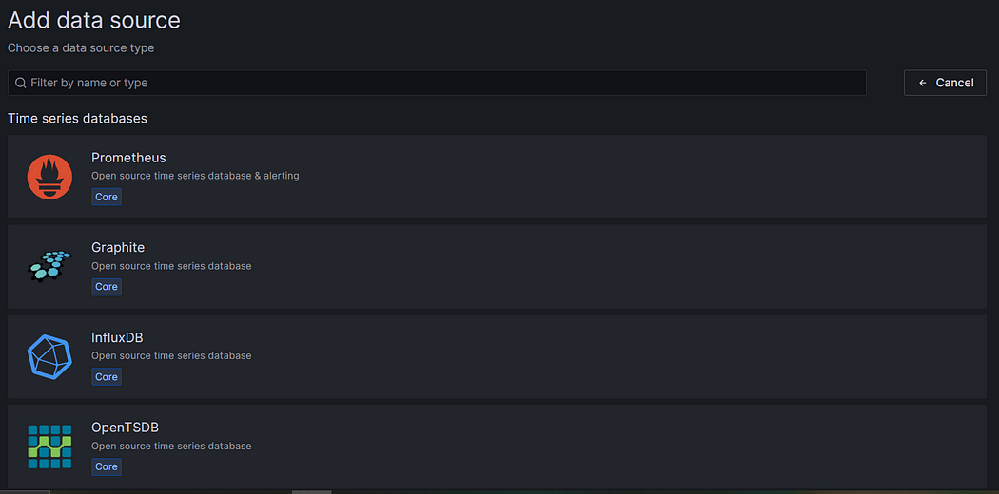
24. In setting paste Prometheus URL and keep other setting as by default and click “Save and Test”
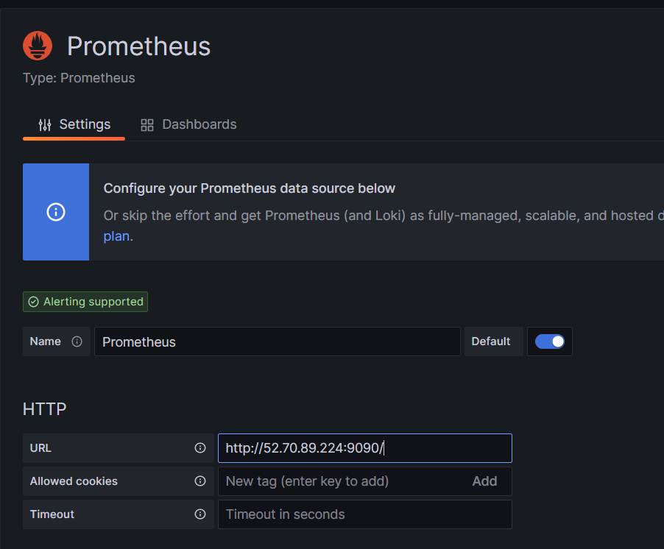
25. After click on “Save and Test” you will see below output
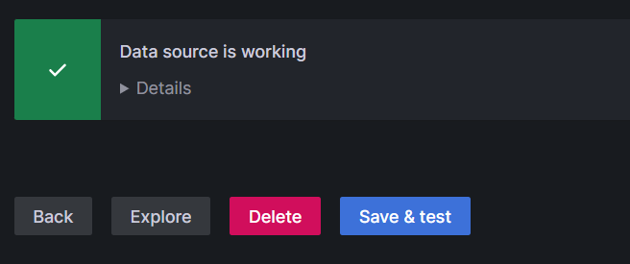
26. Now go to dashboard and in right hand corner click on “+” icon =>New Dashboard => Add visualisation
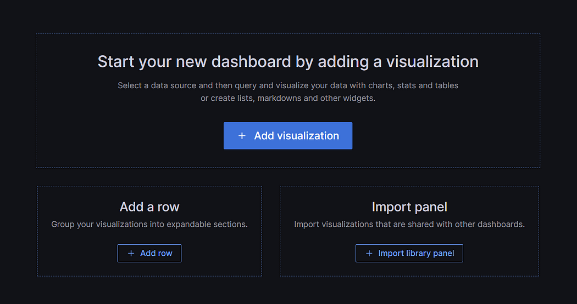
27. In the Metrics browser section add below query. The below query will fetch the number of stopped containers.
engine_daemon_container_states_containers{state="stopped"}
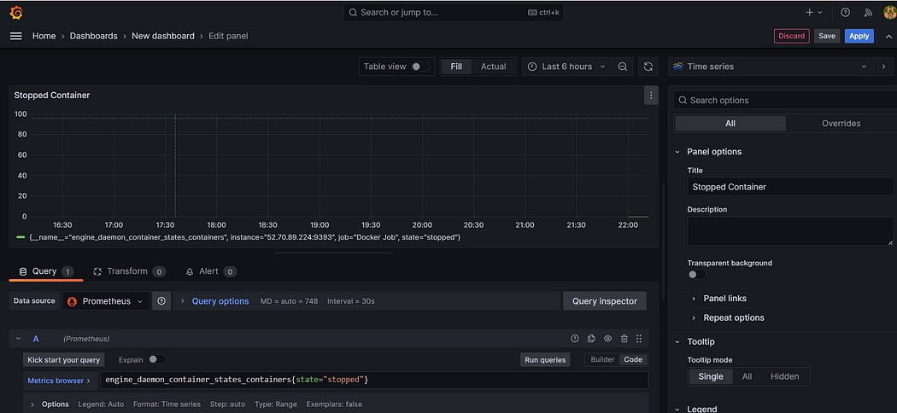
28. then click on apply and save and again click on “+” icon
29. If you want to see data in Stat then click on “Time Series” then you will see multiple visualization, I am selecting “Stat” option
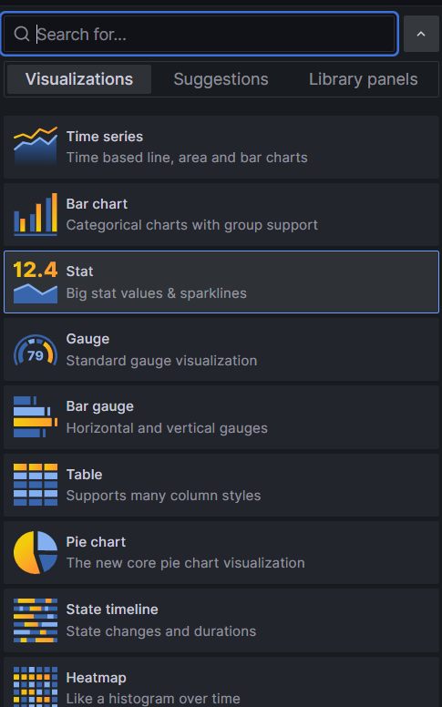
30. Now Follow same process for Paused container,
31. For that click on Add => Visualization

32 . In the Metrics browser section add below query. The below query will fetch the number of paused containers.
engine_daemon_container_states_containers{state="paused"}
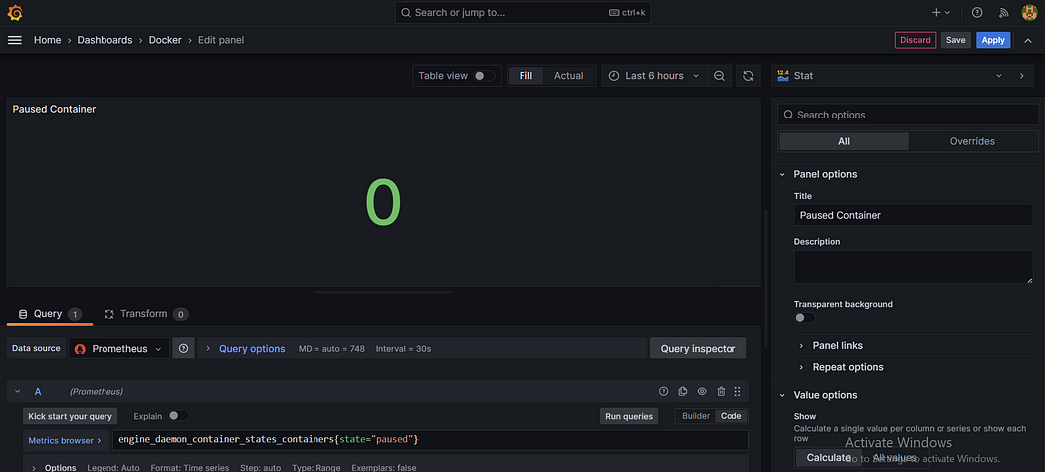
33. Again repeat step 31. In the Metrics browser section add below query. The below query will fetch the number of running containers
engine_daemon_container_states_containers{state="running"}
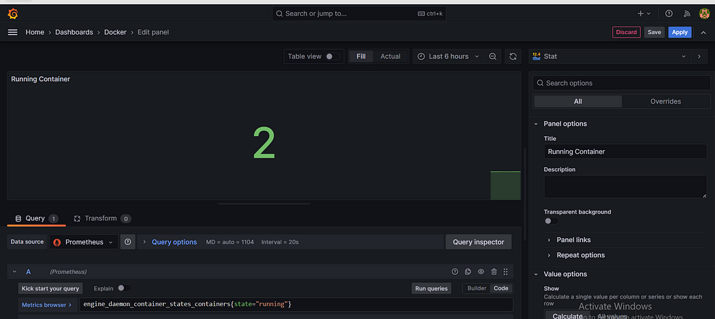
34. Now as you see final dashboard as follow to see final dashboard click on “Apply” button give name to Dashboard you will see such below
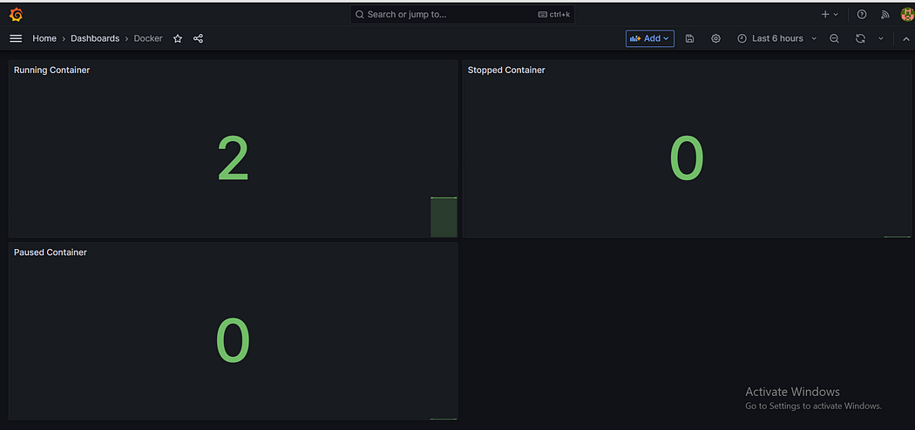
35. As of now my 2 container are running so we see running container 2, if I stop one then you see following output
